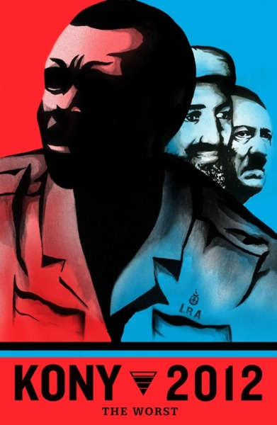
KONY 2012
How many people do you think have watched the KONY2012 film?
Have you?
If so, did you watch it all the way through, not just the first 2 minutes?
How did the film make you feel?

Did you feel it was “too professional”?
Did you do anything in response (like, share, post)? Did you help spread the word?
Do you think people have responded too quickly?

Did you know anything about Joseph Kony prior to watching the film?
Did you know anything about the organisation Invisible Children (those behind the campaign) before watching the film?
Have you heard any of the concerns raised about Invisible Children since becoming aware of KONY2012?
If you could sum up the KONY2012 video in one sentence, what would it be?

The film mentions that people “forget.” Do you think people will care as much about this issue in a month? 6 months? 2 years?

Is there a difference between “knowing” and “caring” about a situation? If so, how might they be different?

Has this film changed the way you view the world? Why/Why not?

Is your only source of information about Joseph Kony from the YouTube film?
What did you feel when you saw Gavin (the film-maker’s son) and Jacob (the Ugandan boy)?

Why do you think the film was made? What results are the film-makers after?

What do you want to see happen as the result of this campaign (does it line up with your last answer???)?

Did you/would you give money towards the campaign (either straight donate or buy a kit)?
Would you wear a Kony2012 Bracelet? Would you accept one if it was given to you?
Do you think the film encourages vandalism?

Do you think Joseph Kony is a Christian? Do you know what the letters LRA stands for?

How do you think the church should respond to KONY2012?

From what you know, do you think Joseph Kony is the worst problem in Africa?

Did you recognise any other names on the ICC most wanted list shown in the film?
How would you feel if Joseph Kony was treated the same way as either Saddam Hussein (captured, tried in a court and executed) or Muammar Gaddafi (killed by a vengeful mob)? Is there a difference? Would one be a “better” form of justice?
BREATHE. READ. THINK… act

